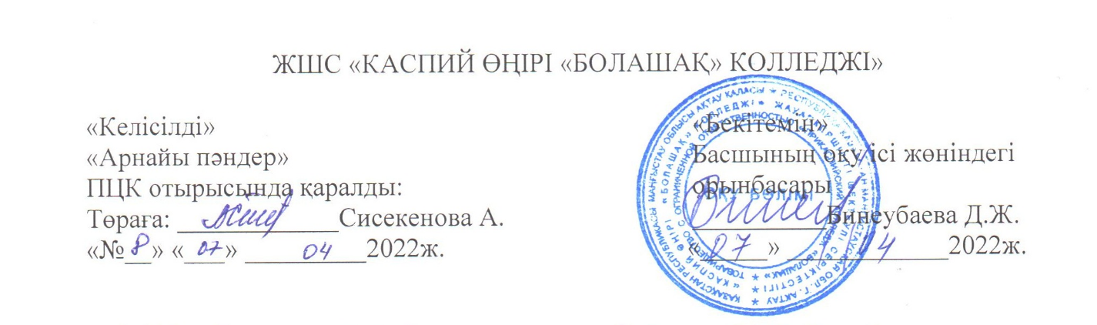

.

0105000 «Бастауыш білім беру» мамандығы бойынша

НОО-19 тобына арналған

«Кәсіби шетел тілі» пәні бойынша сынақ сұрақтары

Билет №1

1. Speaking tasks: My future profession

2. Gramma task.

Билет №2

1. Speaking tasks: My College

2. Gramma task.

Билет №3

1. Speaking tasks: My first teacher

2. Gramma task.

Билет №4

1. Speaking tasks: Kids and their interests

2. Gramma task.

Билет №5

1. Speaking tasks: Rules of our college

2. Gramma task.

Билет №6

1. Speaking tasks: Schools in the USA

2. Gramma task.

Билет №7

1. Speaking tasks: Schools in China

2. Gramma task.

Билет №8

1. Speaking tasks: My favorite subject

2. Gramma task.

Билет №9

1. Speaking tasks: School of my dream

2. Gramma task.

Билет №10

1. Speaking tasks: The main qualities of teacher

2. Gramma task.

Билет №11

1. Speaking tasks: Fairy tale

2. Gramma task.

Билет №12

1. Speaking tasks: When I was a pupil…

2. Gramma task.

Билет №13

1. Speaking tasks: Subjects of primary school

2. Gramma task.

Билет №14

1. Speaking tasks: A modern schools of Kazakhstan

2. Gramma task

Билет №15

1. Speaking tasks: Games with pupils

2. Gramma task

Билет №16

1. Speaking tasks: Internet in our life

2. Gramma task

Билет №17

1. Speaking tasks: The prestige jobs of nowadays

2. Gramma task

Билет №18

1. Speaking tasks: Interesting days of my practice

2. Gramma task

Билет №19

1. Speaking tasks: Appearance of student

2. Gramma task

Билет №20

1. Speaking tasks: Schools in Great Britain

2. Gramma task

Билет №21

1. Speaking tasks: Hobbies of modern children

2. Gramma task

Билет №22

1. Speaking tasks: The role of books

2. Gramma task

Билет №23

1. Speaking tasks: The great teachers

2. Gramma task

Билет №24

1. Speaking tasks: Sport at school

2. Gramma task

Билет №25

1. Speaking tasks: Is it easy to be a teacher?

2. Gramma task

Дайындаған: Сисекенова А.Н.